Market Entry Strategy for an EdTech Startup in Tier-2 Indian Cities

Author- Aarohi Bhatt
Date- 20/1/2025
1. Introduction
1.1 Background
The Indian EdTech sector has witnessed exponential growth, driven by increasing internet penetration, smartphone adoption, and demand for quality education. However, Tier-1 cities (Delhi, Mumbai, Bangalore) are saturated with established players like BYJU’S, Unacademy, and Vedantu. Tier-2 cities (Lucknow, Jaipur, Indore, Coimbatore, etc.) remain underserved despite high demand, presenting a lucrative opportunity for a new EdTech startup.

1.2 Problem Statement
An EdTech startup wants to expand into Tier-2 Indian cities but faces challenges such as:
- Low digital literacy compared to Tier-1 cities.
- Price sensitivity – affordability is a major concern.
- Localized competition from coaching centers and regional players.
- Infrastructure issues (internet connectivity, device availability).

Objective: Develop a data-driven market entry strategy to capture Tier-2 education markets efficiently.

2. Market Analysis
2.1 Why Tier-2 Cities?
- Growing Demand: Rising middle-class aspirations for quality education.
- Less Competition: Fewer established EdTech players compared to metros.
- Government Push: Digital India, PM eVIDYA, and state-level EdTech initiatives.
- Lower CAC (Customer Acquisition Cost): Cheaper marketing than Tier-1 cities.

2.2 Target Audience Segmentation
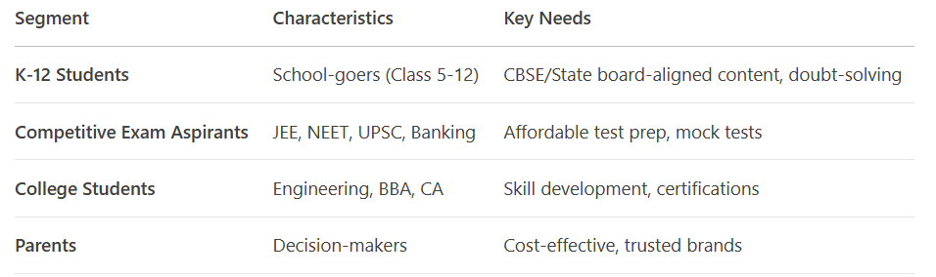
2.3 Competitor Analysis
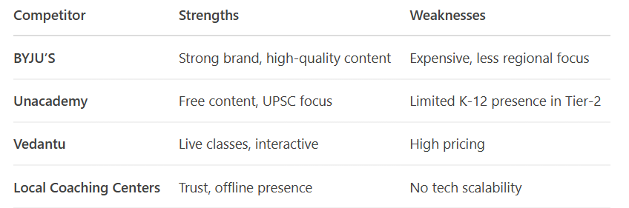
Key Insight: Most competitors focus on high-income urban users, leaving a gap for affordable, vernacular, and hybrid (online + offline) solutions.

3. Market Entry Strategy
3.1 Product Localization
- Vernacular Content: Offer courses in Hindi, Tamil, Telugu, Marathi.
- Affordable Pricing:
- Subscription model: ₹500-1000/month (vs. BYJU’S at ₹2000+).
- Pay-per-course: Micro-payments for single subjects.
- Hybrid Model: Partner with local coaching centers for blended learning.

3.2 Distribution & Sales Strategy
A) Digital Acquisition
- Performance Marketing:
- Facebook/Google Ads (regional language targeting).
- YouTube influencers (local educators, parenting bloggers).
- Referral Program: "Refer a friend, get 1 month free."

B) Offline Acquisition
- School Partnerships: Free demo classes in CBSE/state board schools.
- Local Events: Education fairs, parent seminars.
- Coaching Center Tie-ups: Revenue-sharing model.

3.3 Pricing Strategy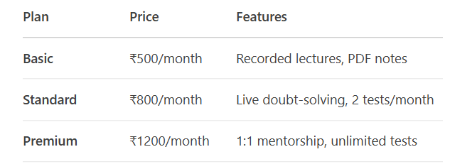
Discounts: Annual payment (10% off), sibling discounts.

3.4 Technology & Infrastructure
- Lightweight App: Optimized for low-end smartphones (under 50MB).
- Offline Mode: Downloadable videos for areas with poor internet.
- WhatsApp Integration: Assignments & reminders via WhatsApp.

4. Implementation Plan
Phase 1: Pilot Launch (3 Months)
- Cities: Jaipur, Lucknow, Coimbatore.
- KPIs:
- 5000+ free sign-ups(to test demand).
- Conversion rate (free to paid users).
- Customer feedback(NPS surveys).

Phase 2: Scaling (6-12 Months)
- Expand to 10+ Tier-2 cities
- Introduce government school partnerships (NEP 2020 alignment).
- Launch scholarship programs for top performers.

Phase 3: Monetization & Growth (12+ Months)
- Upsell advanced courses (coding, spoken English).
- Expand to Tier-3 towns with simplified pricing.

5. Risk Mitigation
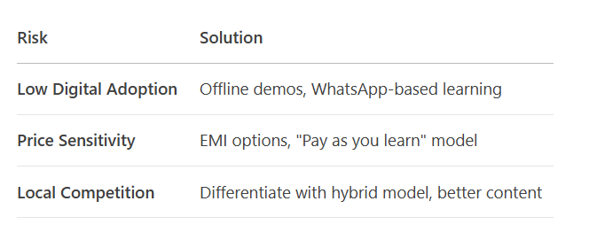

6. Expected Outcomes
- Year 1: 50,000+ users, ₹5 Cr revenue.
- Year 2: Expansion to 20 cities, 200,000+ users.
- Year 3: Break-even, explore Series A funding.

7. Conclusion
Tier-2 Indian cities offer a massive untapped market for EdTech startups willing to adapt to local needs. By combining affordability, vernacular content, and hybrid distribution, a new player can successfully compete against giants while addressing real education gaps.

Recommendation: Start with a pilot in 3 cities, refine based on feedback, then scale aggressively with localized marketing.

Appendix
1. Financial Model
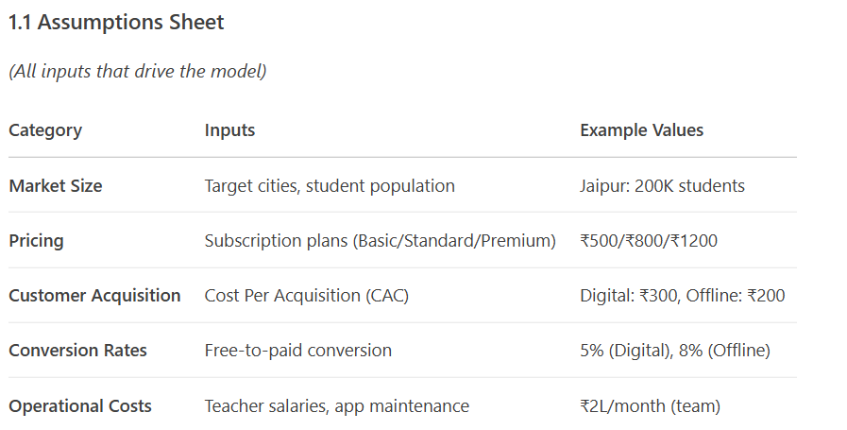

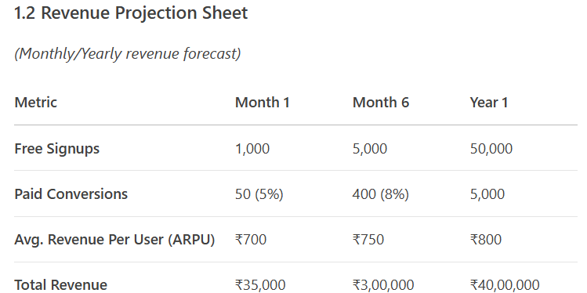

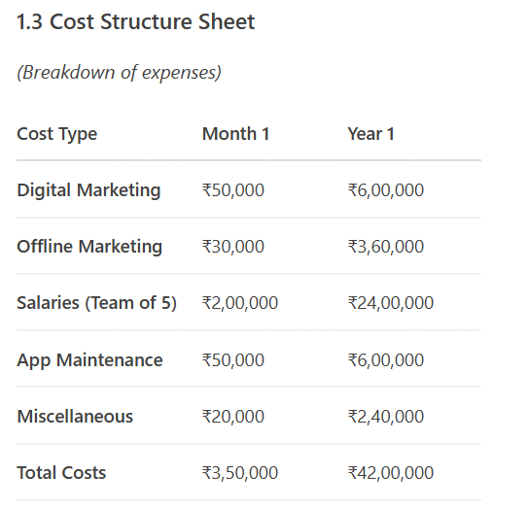

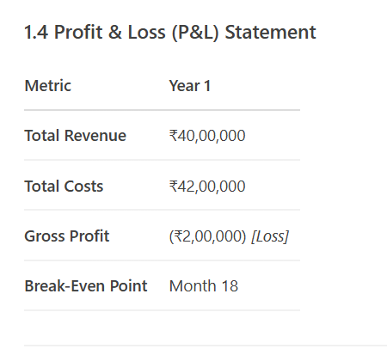
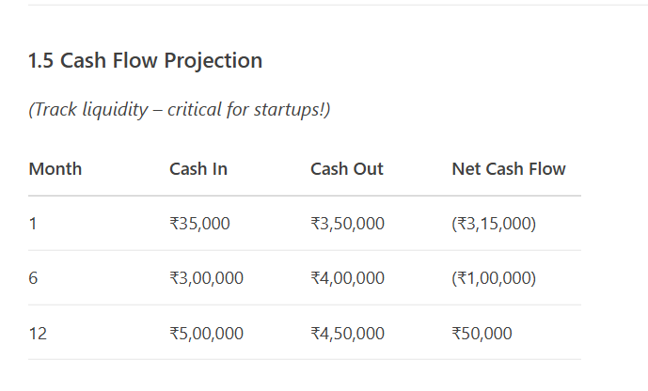
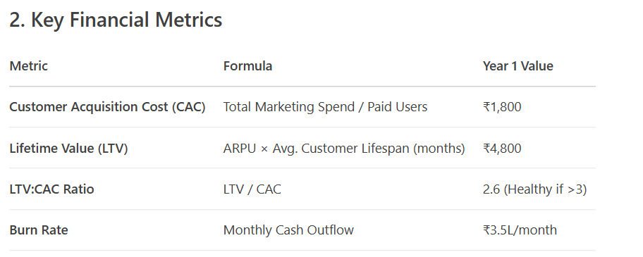

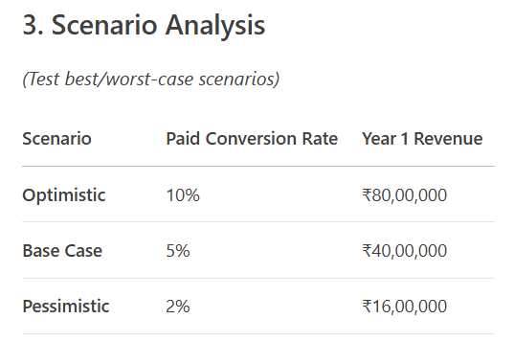
4.SWOT Analysis
5.Customer Survey Template

